Final Project Design Phase
Computer Science - Week 11
Oct 3, 2026 - Version 0.0.4

For complete instructions and project ideas, refer to the assignment in Canvas. Specifically, review the final project requirements before you continue below. If you have not reviewed the project requirements in Canvas (you might have to go to the modules view and check the current or past week's content), you will not be able to properly complete the parts below. In addition, it may be helpful to review the information on this Drafter documentation page.

0) Project Planning and Preparation
Successful programmers spend time planning before they begin coding. After reviewing the project requirements, answer the following questions to help guide your design and development process.
- What concepts from class or previous assignments might help you complete this project? Which programming concepts (loops, conditionals, lists, classes, etc.) do you expect to use? What programming skills do you want to improve while completing this project?
I think dataclasses and lists will be very useful in this project. I want to improve my ability to create useful helper functions when needed, breaking down a large, complex function into smaller, easier to understand ones. I also want to learn how to use a LLM to assist me in coding.

- Which parts of the project do you expect to be the easiest for you? The hardest? Why?
The hardest parts will probably be planning out the website and making sure I design it in a way that will actually work. Once I have that initial design, I think coding the website won’t be that difficult, especially with the help of a LLM.

- Even though you have not yet designed the final project, estimate which tasks will likely require the most time and effort? Which features or components should be implemented first?
The task that will likely require the most time and effort is figuring out the logic to make the quiz actually work. For example, when a certain option is chosen for a question, it will add points towards a certain character. I should probably figure that out first before moving on with the rest of the project.

- What distractions might interfere with your work and how will you minimize them? What resources will you need available while working? What questions, if any, do you still have about the assignment requirements?
Some distractions could include obvious things like my phone, or overall procrastinating with other things or assignments for other classes. I will minimize these by making myself a schedule for when I will work on assignments, and give myself time for breaks.

1) Site Diagram
Create a mock-up of your planned website. We suggest you make the mockup on paper, although you can also use software like PowerPoint or Slides to make a mockup. There is other design software that could also be used, but we strongly encourage you to keep it simple. Do not spend more than 15-30 minutes detailing the mock-up. Your goal should be to make a very quick and dirty diagram, to show that you have some kind of idea.

We recommend drawing each page as a rectangle, and laying out the text, buttons, and other components inside. Then, use arrows to indicate links between pages. Label each page the way you will name each function, and then put labels on the arrows to indicate what the button links. Also write down any parameters that should come into the pages.

In addition to the pages and routes, write down what fields your `State` will have, both their names and types. Think clearly about what data will need to be persistent across the entire website.

Add photo(s) or screenshot(s) of your website mock-up and labeled diagram on the next page.
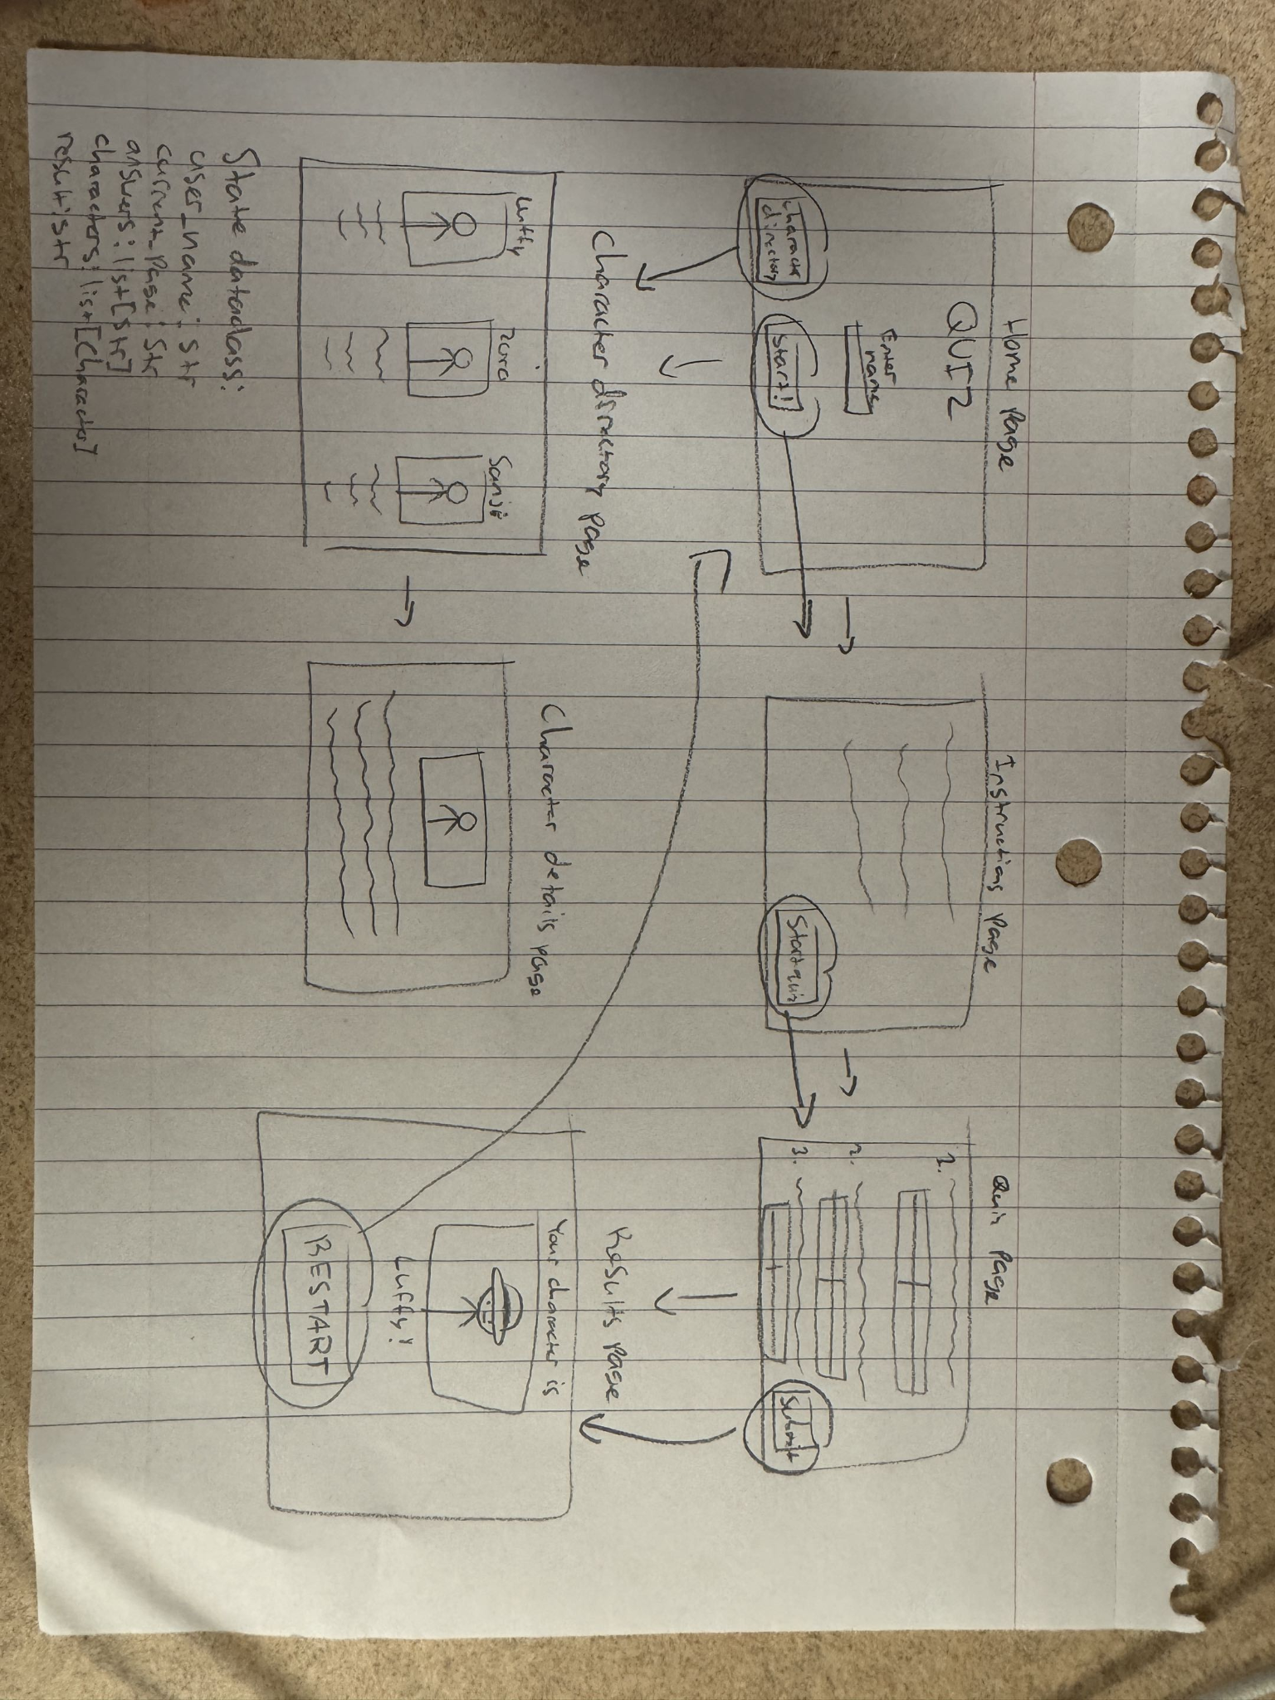2) Implementing Requirements
This table should serve as a draft for how you will implement the requirements into your final project. You may change your ideas later on, but your final site must fulfill all the requirements.

Requirement | Implementation
Purpose/Functionality  A 1-2 sentence description of the purpose or functionality of your site | The purpose of my site is a personality quiz with One Piece characters. It works by asking the user multiple choice questions, and assigning the user a character based on their answers.
State Dataclass Attributes  Minimum of 4 attributes, one of which must be a list/dict of instances of your second dataclass.  Briefly describe each attribute, its type, and how it will be meaningfully modified throughout the site. | State dataclass:  user_name: str (stores the user’s name, modified when they enter it on the home page)  current_page: str (tracks the user’s current page, modified when user changes pages)  answers: list[str] (keeps track of the user’s answers to the quiz questions, modified when the user submits the quiz)  characters: list[Character] (stores Character instances, character scores get updated based on the answers the user inputs)  result: str (stores the name of the character that best matches the user’s answers, modified when the quiz is finished and the character is displayed)
Second Dataclass  Your second dataclass, including its attributes, their types, and how they will be meaningfully modified (if they are modified) | Character dataclass:  name: str (stores character’s name)  description: str (stores a brief description of the character)  traits: list[str] (stores a couple personality traits of the character)  score: int (tracks how many points the character has based on the user’s answers, modified as the quiz is taken place and questions are answered)
Routes (minimum 7)  The names of your route functions | home: home page, user enters their name  instructions: explains the quiz  quiz: displays the questions and inputs  submit_quiz: processes answers and calculates scores  results: displays character that best matches the user  character_directory: displays the characters available in the quiz and their descriptions  character_details: shows more information about the selected character  restart: restarts the quiz so the user can take it again
Pages (minimum 5)  A brief description of the pages in your site | Home page: Classic home page for the quiz, area for user to input their name, button to move on to the instructions  Instructions page: Explains how the quiz will work, how many questions there are, button to move on to the first question  Quiz page: Displays quiz questions, users answer multiple choice questions by clicking buttons, button to submit quiz  Results page: Displays the character that best matches the user based on their answers to the quiz, has button to retake quiz if desired  Character directory page: Displays the characters able to be seen at the end of the quiz, shows names, personality traits  Character details page: Displays more detailed information about a specific character selected from the character directory page, shows a description
User Input (minimum 3)  Description of user input components (TextBox, TextArea, CheckBox, or SelectBox) and their purposes  For more information on these input types, see Drafter Documentation. | Enter name (TextBox): user is able to enter their name  Question 1 (SelectBox): user answers question, adds points to certain character  Question 2 (SelectBox): user answers question, adds points to certain character  Question 3 (SelectBox): user answers question, adds points to certain character  Question 4 (SelectBox): user answers question, adds points to certain character  Question 5 (SelectBox): user answers question, adds points to certain character
If Statements (minimum 3)  Brief description of what will be evaluated in your if statements and how they will meaningfully change the logic of the site | If statement 1: checks whether or not the user entered their name on the home page. If entered, they can move on, if not entered, they are prompted to enter a name.  If statement 2: checks whether or not all quiz questions were answered. If the user answered all questions, the results page is displayed when the submit button is pressed. If not all of the questions were answered, it prompts the user to answer all questions.  If statement 3: determines character with highest score. After calculating scores, it checks what character has the highest score. If a character has a higher score than the current best match, that character is displayed instead.  If statement 4: checks if the user wants to restart. If the player presses the restart button, answers and scores are reset, and the quiz starting page is shown.
Loop (minimum 1)  This loop must iterate over the list/dict of dataclass instances in your State attribute.  Description of this loop and why it is meaningful to the site | Loop iterates through characters list in State dataclass to determine which character is the best match based on the answers. Allows the program to evaluate automatically rather than checking manually.

LLM Conversation
If you used an LLM in any part of this work, copy and paste every part of that conversation below. Otherwise, you may be given a zero for the assignment. Obviously, these words will not all be yours, and this is the exception to the requirement at the top of this assignment that all responses be in your own words. If you did not use an LLM to assist you in this assignment, simply say so below.
I am a computer science student and for my final project I have to develop a web application with python and Drafter. It has to have at least 7 routes, 5 pages, a State dataclass with at least 4 fields (with at least one field being a list of class instances or a dictionary of class instances, and the fields need to be meaningfully modified in at least one route, they can't be constants), a second dataclass, at least 3 input fields, at least 3 meaningful if statements, at least 1 loop that iterates over an attribute of the list of class instances or dictionary of class instances in a meaningful way, and no global variables. The project I am moving forward with is a "What One Piece Character Are You?" quiz, where based on the answers the user gives to the questions, it will show what One Piece character they relate with the most.

For the requirements I have to explain:
-State dataclass attributes, briefly describing each attribute, its type, and how they will be meaningfully modified (one has to be a list/dict)
-The second dataclass, its attributes along with types, and if they are going to be modified, how they will be modified (don't have to be modified)
-The names of the minimum 7 routes
-Brief description of the minimum 5 pages
-Description of the minimum 3 user inputs (TextBox, TextArea, CheckBox, or SelectBox), and the purposes of these inputs (don't have to all be the same type of input, or can be all the same)
-Brief description of the minimum 3 if statements and how they will meaningfully change the logic of the site
-Minimum of 1 loop that iterates over the list/dict in the State, brief description of the loop and why it is meaningful
…
Your "What One Piece Character Are You?" quiz is a great choice for this project! It gives you a straightforward way to demonstrate all the required programming concepts without making the application too complicated for a CS1 final project.
I recommend building it as a personality quiz that assigns points to different One Piece characters based on the user's answers. At the end, the application calculates which character has the highest matching score and displays the result.
Below is a project plan organized around each of your professor's requirements. I've designed it so that every requirement has a clear purpose in your application.
Project Plan: What One Piece Character Are You?
1. State dataclass attributes
Your State dataclass will keep track of the user's progress through the quiz, their answers, and the character results.
I recommend using these five attributes:
Attribute
Type
Purpose and how it is modified
user_name
str
Stores the user's name. Modified when the user enters their name on the home page.
current_page
str
Tracks which page the user is currently viewing. Modified when they navigate between pages.
answers
list[str]
Stores the user's answers to the quiz questions. New answers are added when the user submits their quiz.
characters
list[Character]
Stores instances of the Character dataclass. Character scores are updated based on the user's answers.
result
str
Stores the name of the One Piece character that best matches the user's answers. Modified after the quiz is completed.

Why this works:
You have five State attributes, exceeding the required four.
The characters attribute is a list of class instances.
The answers list changes whenever a user submits their quiz.
The character scores change depending on the user's answers.
The result changes after the quiz is evaluated.
Most importantly, these attributes aren't just storing permanent information. They actively change as the user interacts with the application.
2. Second dataclass
Your second dataclass will be called Character.
Each Character instance represents a different One Piece character and contains information used to determine how well that character matches the user's personality.
I recommend starting with these five characters:

Monkey D. Luffy
Adventurous, carefree, loyal

Roronoa Zoro
Determined, disciplined, independent

Nami
Intelligent, practical, resourceful

Sanji
Compassionate, protective, thoughtful

Nico Robin
Curious, analytical, calm
Character dataclass attributes:
Attribute
Type
Purpose and modification
name
str
Stores the character's name. Does not need to change.
description
str
Stores a short personality description. Does not need to change.
traits
list[str]
Stores personality traits associated with the character. Does not need to change.
score
int
Tracks how many points the character receives from the user's answers. Modified throughout quiz evaluation.

For example, a Luffy instance might have the following information:
Name: Monkey D. Luffy
Description: A carefree and adventurous person who values friendship.
Traits: Adventurous, carefree, loyal
Score: 0
You would create five Character instances and place them inside the characters list in State.
Why this dataclass is useful: Rather than creating separate variables for every character, you can store all the characters in one list and use a loop to evaluate them.
3. Minimum of 7 routes
I recommend implementing 8 routes so that you comfortably exceed the requirement.
Route name
Purpose
home
Displays the welcome page and allows users to enter their name.
instructions
Explains how the personality quiz works and what users should expect.
quiz
Displays the personality questions and input fields.
submit_quiz
Processes the user's answers and calculates character scores.
results
Displays the character that best matches the user's personality.
character_directory
Displays all five available One Piece characters and their descriptions.
character_details
Displays more information about a selected character.
restart
Resets the quiz so the user can take it again.

A useful distinction: submit_quiz is a processing route, rather than a separate page. That's perfectly reasonable because routes can perform actions as well as display pages.
4. Minimum of 5 pages
Your application will have six pages.
Page 1: Home Page
Page

This is the first page users see. It introduces the quiz, provides a short description, and includes a TextBox where users enter their names. A button takes them to the instructions.
Page 2: Instructions Page

Explains the purpose of the quiz, how many questions users will answer, and how their answers determine their character match. A start button takes users to the quiz.
Page 3: Quiz Page

Displays three or more personality questions. Users select their answers using SelectBox inputs. When they finish, they submit their answers to be evaluated.
Page 4: Results Page

Displays the character that best matches the user's personality. Shows the character's name, image, description, and matching personality traits. Also includes an option to retake the quiz.
Page 5: Character Directory

Displays all five characters included in the quiz. Users can browse their names, descriptions, and personality traits.
Page 6: Character Details Page

Displays more detailed information about an individual character selected from the directory, including their personality and traits.
5. Minimum of 3 user inputs
I recommend using four input fields. These are all realistic to implement using Drafter's SelectBox and TextBox components.
Input
Drafter component
Purpose
User's name
TextBox
Allows the user to enter their name on the home page.
Question 1: How do you approach a challenge?
SelectBox
Allows users to choose between answers such as facing it head-on, planning carefully, or asking for help.
Question 2: What matters most to you?
SelectBox
Allows users to choose values such as friendship, independence, knowledge, or success.
Question 3: How would your friends describe you?
SelectBox
Allows users to choose personality traits such as adventurous, responsible, intelligent, or caring.

Example quiz questions and answers:
Question 1: How do you approach a challenge?
I face it head-on without hesitation
I make a plan before taking action
I think carefully before deciding
I focus on helping everyone involved
Question 2: What matters most to you?
Friendship and loyalty
Independence and determination
Knowledge and curiosity
Helping and protecting others
Question 3: How would your friends describe you?
Adventurous and energetic
Responsible and practical
Intelligent and observant
Caring and thoughtful
These are illustrative quiz inputs, not a final scoring system.
You can add more questions later, but I recommend starting with three to keep the project manageable.
6. Minimum of 3 meaningful if statements
Your application can include several meaningful conditional statements.
Here are four examples:
If statement 1: Checking whether the user entered their name
When the user clicks the start button, the program checks whether the name field is empty.
If the user entered a name, they can proceed to the instructions page.
Otherwise, the application displays a message asking them to enter their name.
If statement 2: Checking whether all quiz questions have been answered
When the user submits the quiz, the program checks whether they answered all three questions.
If all questions have answers, the application calculates their character match.
Otherwise, the application displays a message asking them to complete the unanswered questions.
If statement 3: Determining the character with the highest score
After calculating the scores, the program checks which character has the highest score.
If a character has a higher score than the current best match, that character becomes the new result.
This ensures the application displays the character who received the most points.
If statement 4: Checking whether the user wants to restart
When the user clicks the restart button, the program resets their answers and character scores.
The user is returned to the quiz's starting page.
This allows them to take the quiz again without their previous results affecting the new quiz.
These are meaningful because they change what the application does based on user input and program data.
7. Minimum of 1 meaningful loop
This is one of the most important parts of your project because it demonstrates why you created the Character dataclass and stored its instances in a list.
The loop will iterate through the characters list in the State dataclass to determine which One Piece character best matches the user's answers.
Here is how it will work:
When the user submits their quiz, the program retrieves their answers.
The program loops through every Character instance stored in state.characters.
For each character, the program compares their personality traits with the traits associated with the user's answers.
Every time a character matches an answer, their score increases.
After checking all five characters, the program identifies which character has the highest score.
The winning character's name is stored in state.result.
For example:
Character
Matching answers
Final score
Luffy
3
3
Zoro
1
1
Nami
2
2
Sanji
2
2
Robin
1
1

Example result The application would display Luffy because he received the highest score.
Why this loop is meaningful: It allows the program to evaluate every character automatically rather than manually checking each character individually. It also makes it easy to add more characters to the quiz in the future.
How everything fits together
Here is the overall structure of your application:
Home Page
Enter your name
Instructions Page
Learn how the quiz works
Quiz Page
Answer personality questions
Submit Quiz
Check answers, loop through characters, calculate scores
Results Page
Display the best character match
Character Directory
Browse characters
Character Details
Explore a character
Users can also restart the quiz and return to the beginning.
Final requirements checklist
Professor's requirement
Your project
At least 7 routes
8 routes
At least 5 pages
6 pages
State dataclass with 4+ fields
5 attributes
List/dictionary of class instances
characters: list[Character]
Meaningfully modified State fields
All 5 fields have a purpose and can be modified
Second dataclass
Character
At least 3 input fields
4 inputs
At least 3 meaningful if statements
4 examples
At least 1 meaningful loop
Loop through Character instances
No global variables
All application data stored in State

All listed requirements addressed
My recommendations before you start coding
There are three things I would pay particular attention to:
1. Keep the scoring system simple. You don't need a complicated personality algorithm. Assign points to characters based on selected answers and choose the highest score. Decide how ties will be handled, such as displaying the first character with the highest score.
2. Don't make the character information overly complicated. Five characters with four attributes each are enough to demonstrate dataclasses, lists, loops, and conditionals.
3. Be careful with Drafter's State management. Since Drafter runs Python in the browser using Pyodide and doesn't require a backend or database, you can keep all quiz information in State. You don't need user accounts, a server, or a database for this project.
One additional suggestion: Make sure the restart route resets the character scores as well as the answers. Otherwise, a user's previous quiz could influence their next result.
Overall, I think this is a very achievable CS1 final project. It has enough functionality to feel like a real web application, while the underlying programming concepts remain relatively straightforward.
My recommended next step would be to develop the actual scoring system: deciding which answers give points to Luffy, Zoro, Nami, Sanji, and Robin. That will give you a clear foundation before you start implementing the Drafter routes.

Final Submission
When you are finished, download this file as a Word Document (docx) and upload the file to the appropriate assignment on Canvas.

